# **Redline Pipeline Documentation**

**Author:** Eugene Grois  **Date:** 8/30/2025

## **Introduction**

This document describes a Playbook-scoped AI framework for redlining legal contracts (initially NDAs). It explains the end-to-end pipeline: document clause extraction, Playbook-document clause mapping, binary acceptability decisions, and fix synthesis – and the evaluation protocol used to verify accuracy and reproducibility.

## **Design Principles and Constraints**

* **Playbook as single source of truth.** All standards, exemplars, and red-flag definitions come from the Playbook. The system does not import external legal knowledge.
* **Mapping-first discipline.** Each Playbook clause is uniquely associated with at most one clause in the NDA (or marked absent). This prevents duplicate judgments and forces traceable alignment between policy and text.
* **Determinism where feasible.** Thresholds, tie-breakers, and logging are specified so that the same inputs and settings produce the same outputs. Structural heuristics, rule-based matching, and explicit mapping matrices combine to ensure repeatability, transparency, and fast debugging.
* **Robustness to document variability and semantic ambiguity.** Reliably handle structural and lexical variation, as well as ambiguous meaning, by combining precise string matching, semantic similarity via embeddings, and – when needed – LLM-powered generative reasoning.
* **Evaluation is integral to the process.** Measurement of mapping, decision quality, snippet alignment, and fix suitability is built in, not an afterthought.

## **1. Clause Extraction from NDA Document**

The first stage of the redlining pipeline breaks the source NDA into constituent clauses and produces a structured output (bad_document_clauses.json). The process is engineered for robustness across diverse NDA formats, numbering styles, and formatting inconsistencies.

**Key Steps**

* **Preprocessing:** Clean and normalize raw NDA text, handling inconsistent line breaks, whitespace, and non-standard section delimiters.
* **Clause Heading Detection:** Detect clause boundaries using a combination of regular expressions and heading-recognition rules that are resilient to numbered, unnumbered, and mixed formats (e.g., “1.”, “Section 1”, “Term and Termination”, or simply “Termination”).
* **Signature Block Exclusion:** Apply heuristics to detect and exclude common signature blocks (e.g., sections starting with “IN WITNESS WHEREOF” or similar language) to avoid misclassifying them as substantive clauses.
* **Clause Extraction:** For each detected heading, capture all following text up to the next heading or document end, and output a list of objects with fields such as clause_name and clause_content.
* **Result:** The output bad_document_clauses.json contains one entry per clause, faithfully preserving the structure and content of the source NDA for downstream analysis.

This stage performs structural segmentation only; no legal interpretation is applied here.

## **2. Mapping Playbook Clauses to NDA Clauses**

This step produces a unique assignment between abstract **Playbook** clause types (e.g., “Indemnification”, “Notices”) and the actual NDA clauses identified above. Mapping is required because clause names, formats, and positions vary across contracts.

**Algorithm Overview**

* **LLM-Based Match Score Matrix:** Compare each Playbook clause against every NDA clause with an LLM that scores the semantic/legal match on a 0–10 scale, considering both clause headings and content. The result is a **match heatmap** (Playbook × NDA clauses).
* **Deterministic One-to-One Assignment:** Use a greedy, uniqueness-enforcing assignment algorithm that processes each Playbook clause:  
  + Assign the highest-scoring NDA clause above a fixed threshold (e.g., ≥ 6).
  + Once assigned, an NDA clause cannot be mapped to any other Playbook clause.
  + Unmatched Playbook clauses (no score ≥ threshold) are assigned **“None.”**
* **Second-Pass Recovery:** Any Playbook clause left unmapped after the first pass is re-evaluated against only the set of unassigned NDA clauses (optionally with a focused LLM prompt) to maximize coverage.
* **Outcome:** A reliable, human-interpretable, and unique Playbook-clause → NDA-clause mapping, exported to a mapping file for the redlining pipeline.

## **3. Redlining Pipeline and Algorithms**

After mapping Playbook clause types to their corresponding NDA clauses, the pipeline must determine – *for each mapped pair* – whether the NDA clause is compliant, problematic, or missing, and generate appropriate redline suggestions where needed. This decision-making process is tightly anchored to Playbook standards and avoids external legal knowledge.

**Pipeline Steps**

* **Clause Selection:** For each Playbook clause, retrieve the mapped NDA clause (or “None”) for analysis.
* **Acceptability Judgment:** A carefully engineered LLM prompt instructs the model to make a binary, auditable decision about each clause. The prompt integrates the following Playbook fields:  
  + **Clause Definition & Provision Definition:** Legal context, intended scope, and high-level purpose of the clause type.
  + **Review Instructions:** An actionable checklist of key requirements, elements, and explicit Red Flags the clause must address or avoid.
  + **Ideal Example:** The gold-standard version for maximum protection.
  + **Acceptable Example:** The minimum bar considered compliant and safe.
  + **Red Flags:** Language, omissions, or conditions that should automatically result in a flag.
* **Instructions to the LLM (summary):**
  + *Begin by reviewing the definitions for intent and context.*
  + *Treat the* ***review instructions*** *as a checklist; all must be substantially satisfied.*
  + *If the clause meets or exceeds the* ***Acceptable Example*** *(allowing minor omissions or phrasing differences), mark* ***ACCEPTABLE (“YES”)****.*
  + *If the clause is weaker, more permissive, or introduces new risk relative to* ***Acceptable****, mark* ***PROBLEMATIC (“NO”)****.*
  + ***Red Flags*** *must always be called out. Explanations must be brief and must cite which checklist items were met or missed.*
  + *The model is primed to synthesize context, compliance, and best practice—not merely compare literal strings.*

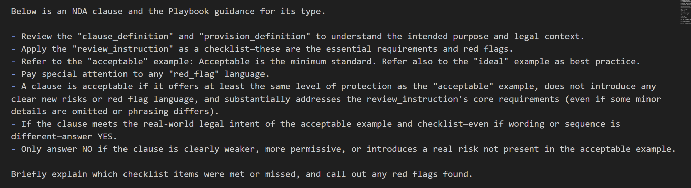

**Figure 1**. Actual LLM prompt for identifying problematic NDA clauses heavily grounded in the Playbook. Note the interactivity among the Playbook guidance fields: review_instructions, red_flags, clause_definition, provision_definition, ideal and acceptable examples.

* **Redline Suggestion:** For every problematic clause, the pipeline supplies a replacement/fix chosen from the Playbook’s **Ideal** or **Fallback** examples, formatted to match the original NDA’s style where possible.
* **Results Output (structured JSON):**
  + text_snippet: the actual NDA text being flagged
  + playbook_clause_reference: the Playbook clause type being applied
  + suggested_fix: the replacement language to be considered

Model inputs in this stage are restricted to Playbook fields and the mapped NDA clause text; no external legal knowledge is incorporated.

## **4. Evaluation Methodology & Metrics**

### **Overview and Rationale**

The evaluation protocol is not an afterthought, but an integral part of the redlining pipeline. It measures both the accuracy and robustness of the system at multiple levels:

* **Per NDA clause** (Did the system correctly flag or ignore each clause?)
* **Per Playbook clause** (Did the system apply the correct policy to each required clause type?)
* **Suggested fix similarity** (Are the system’s recommendations close in meaning and quality to the ground truth?)

This multi-layered evaluation ensures both fine-grained accountability and real-world impact—crucial for high-stakes legal domains where a single missed flag or misapplied fix can have significant consequences.

**A. Metrics Tracked**

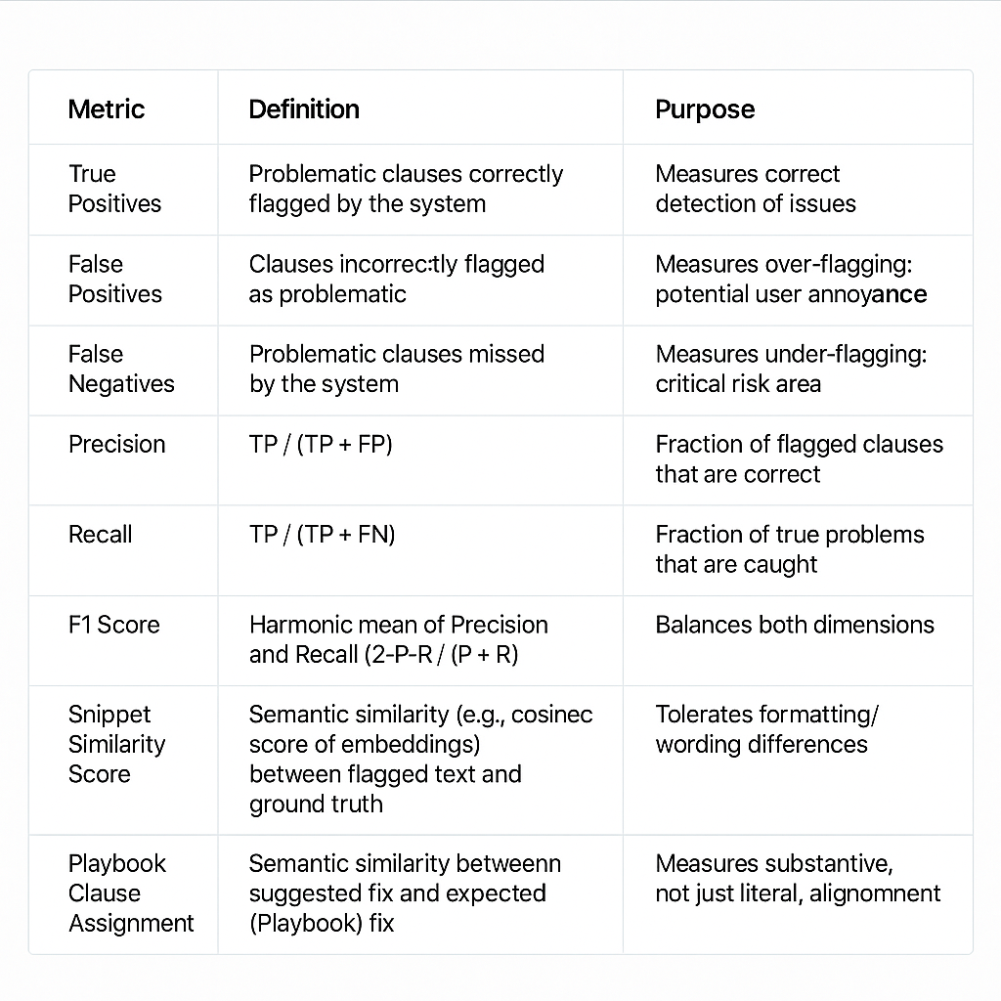

### **B. Levels of Evaluation and Their Significance**

#### **1. NDA Clause-Level Evaluation**

* **What is measured:** For each clause in the extracted NDA, does the system:  
  + Flag it correctly as problematic (TP), incorrectly (FP), or miss a required flag (FN)?
  + Produce a flagged snippet and suggested fix that semantically match ground truth?
  + Correctly associate each flagged clause with the relevant Playbook policy?
* **How it works:**
  + **Matching** is done first by strict substring (exact text overlap), then by semantic similarity (embeddings) to allow for formatting or minor linguistic differences.
  + **Fixes** are scored via semantic similarity, ensuring that substantive alignment is rewarded even if wording varies.
* **Interpretation:** High F1 at this level means reliable clause-by-clause review; any error is directly actionable and traceable to a specific clause or policy.

#### **2. Playbook Clause-Level Evaluation**

* **What is measured:** For each canonical Playbook clause type (policy), does the system ever flag at least one NDA clause corresponding to it?
* **How it works:**
  + If the system finds and flags any instance of a Playbook policy in the NDA, it counts as a match, even if the NDA’s structure or headings differ from expectations.
* **Why it matters:**
  + This level reflects the broader *compliance landscape*: are all required legal policies present and correctly scrutinized, regardless of their placement in the NDA?
  + It is possible to have perfect Playbook-level F1 even if clause-level F1 is imperfect – especially in documents where clauses are merged, split, or distributed differently than in the Playbook.

#### **3. Suggested Fix Evaluation**

* **What is measured:** For each flagged clause, how closely does the system’s recommended fix align with the Playbook’s ideal or fallback language?
* **How it works:**
  + Semantic similarity (typically via cosine similarity of embeddings) is used to score both content and intent, allowing for stylistic or formatting variation.
* **Significance:**
  + This avoids penalizing the system for using legally equivalent but differently worded fixes.
  + Encourages generative flexibility while preserving substantive correctness.

**C. Types of Evaluation Errors and Traceability**

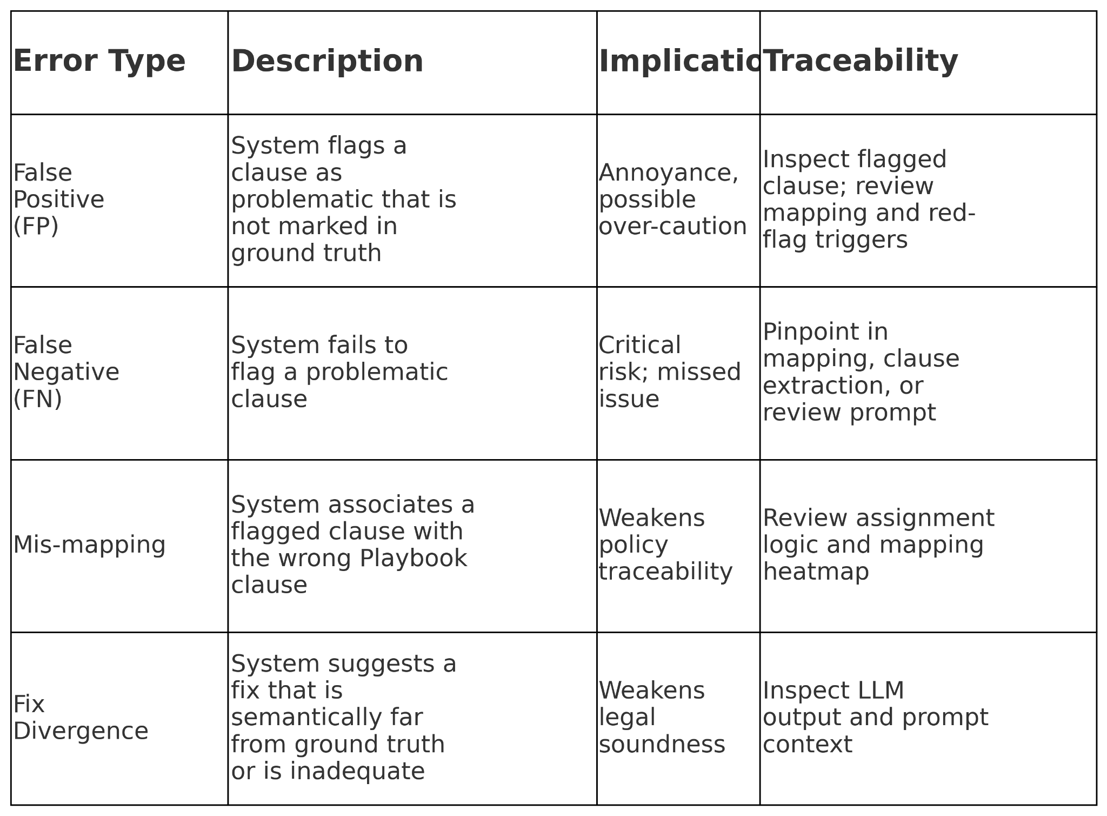

Every error is logged with context – making it possible to rapidly diagnose if the failure was due to clause extraction, semantic mapping, prompt structure, or LLM output. This supports not just score reporting, but actionable quality control and iterative refinement.

**D. Interpreting Metrics: Real Example**

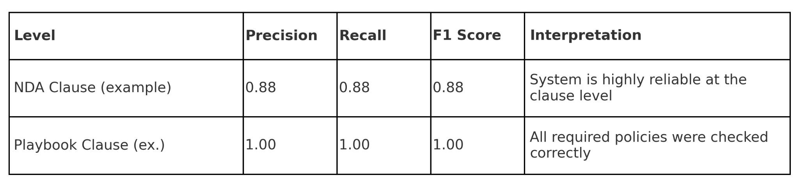

* **Discrepancies (FPs or FNs)** are often due to ambiguous or overlapping clauses—e.g., “Miscellaneous” vs. “Governing Law”—which the system can nonetheless recognize via high semantic scores, justifying traceable “explainable failures” rather than silent errors.

### **E. In summary,**

By combining structural matching, semantic similarity, and deterministic policy assignment, the evaluation protocol ensures that the system’s performance is not just numerically strong, but **explainable, actionable, and robust to real-world document variability**. This approach uniquely enables both reproducible benchmarking and targeted error correction—crucial for building trust in legal AI workflows.

## **Addendum: Explanation of Evaluation Results**

### **A. Overall Summary of Evaluation Results**

The evaluation presents a comprehensive analysis of the NDA redlining system, comparing automated outputs with human-verified (expected) results at both the individual NDA-clause level and the Playbook-clause level.

#### **1) NDA Clause-Level Evaluation**

* **Metrics (Per NDA Clause):**
  + True Positives (TP): **7**
  + False Positives (FP): **1**
  + False Negatives (FN): **1**
  + Precision, Recall, F1: **All 0.88**
* Interpretation: Of all NDA clauses that should have been flagged as problematic, 7 were correctly identified (TP), 1 clause was flagged unnecessarily (FP), and 1 problematic clause was missed (FN). The pipeline achieves high – but not perfect – precision and recall at this level.
* **Breakdown by Clause:** For each NDA clause, the results show:  
  + Which Playbook clause (e.g., “Confidential Information”, “Indemnity”) was assigned in expected (human) vs. actual (system) outputs.
  + Whether the clause was flagged as problematic (“Flagged: YES/NO”) in both expected and actual.
  + Similarity scores for both the text snippet and the suggested fix—indicating how close the system’s output is to the expected redline.  
     Most clauses align closely, with high similarity scores (typically > 0.85) for snippet and fix where flagged. Where neither system nor human flagged a clause, similarities are marked “N/A.”  
     Discrepancies are visible in NDA clauses “**Governing Law; Oral Agreements**” and “**Miscellaneous**”**,** where the system missed one problematic clause and over-flagged another, producing the observed FP/FN. (See discussion Addendum, part B.)

#### **2) Playbook Clause-Level Evaluation**

* **Metrics (Per Playbook Clause):**
  + True Positives (TP): **8**
  + False Positives (FP): **0**
  + False Negatives (FN): **0**
  + Precision, Recall, F1: **All 1.00**
* Interpretation: At the Playbook-clause level – i.e., whether each policy (e.g., “Indemnity”, “Assignment”) was ever triggered somewhere in the NDA – matches are perfect. Every required Playbook clause was found and flagged correctly, and no unnecessary Playbook clauses were added.
* **Breakdown by Playbook Clause:** For each Playbook clause, the report shows which NDA clause(s) it mapped to in expected vs. actual outputs. In almost every case, the mapping is perfect. The only minor discrepancy appears for the **“General”** Playbook clause, where the system mapped to a different NDA clause than expected – reflecting small differences in clause structuring or LLM interpretation while still covering the substantive ground.

#### **3) General Trends and Key Takeaways** The system shows very high fidelity to expected redlining, with near-perfect clause-level matches and 100% alignment at the policy/Playbook level. Minor mismatches are traceable and interpretable, typically arising from ambiguous or overlapping NDA clauses. The similarity metrics provide granular evidence of output quality, supporting both qualitative and quantitative evaluation. Overall, the results validate that the pipeline is reliable for both clause-by-clause review and for tracking compliance with Playbook standards.

### **B. Interpreting the “General” Playbook Clause Mapping: Semantic Robustness in Action**

“Catch-all” or omnibus provisions often appear under different headings and wording but serve the same legal function.

**What Happened**

* The expected output (human reference) associated “**Governing Law; Oral Agreements”** with the **General** Playbook clause.
* The actual system output mapped **“Miscellaneous”** to the **General** Playbook clause.  
   At first glance, this looks like a discrepancy: the system “flagged” a different section than the human reviewer.

**Why Both Results Are Correct** Both sections serve the same legal function. In many contracts, content appearing under “Governing Law” in one document may be placed in “Miscellaneous” in another. The language is highly similar; placement is a drafting choice.

**Figure 2**.  **Playbook vs NDA Clauses Match Scores** as assigned by LLM.

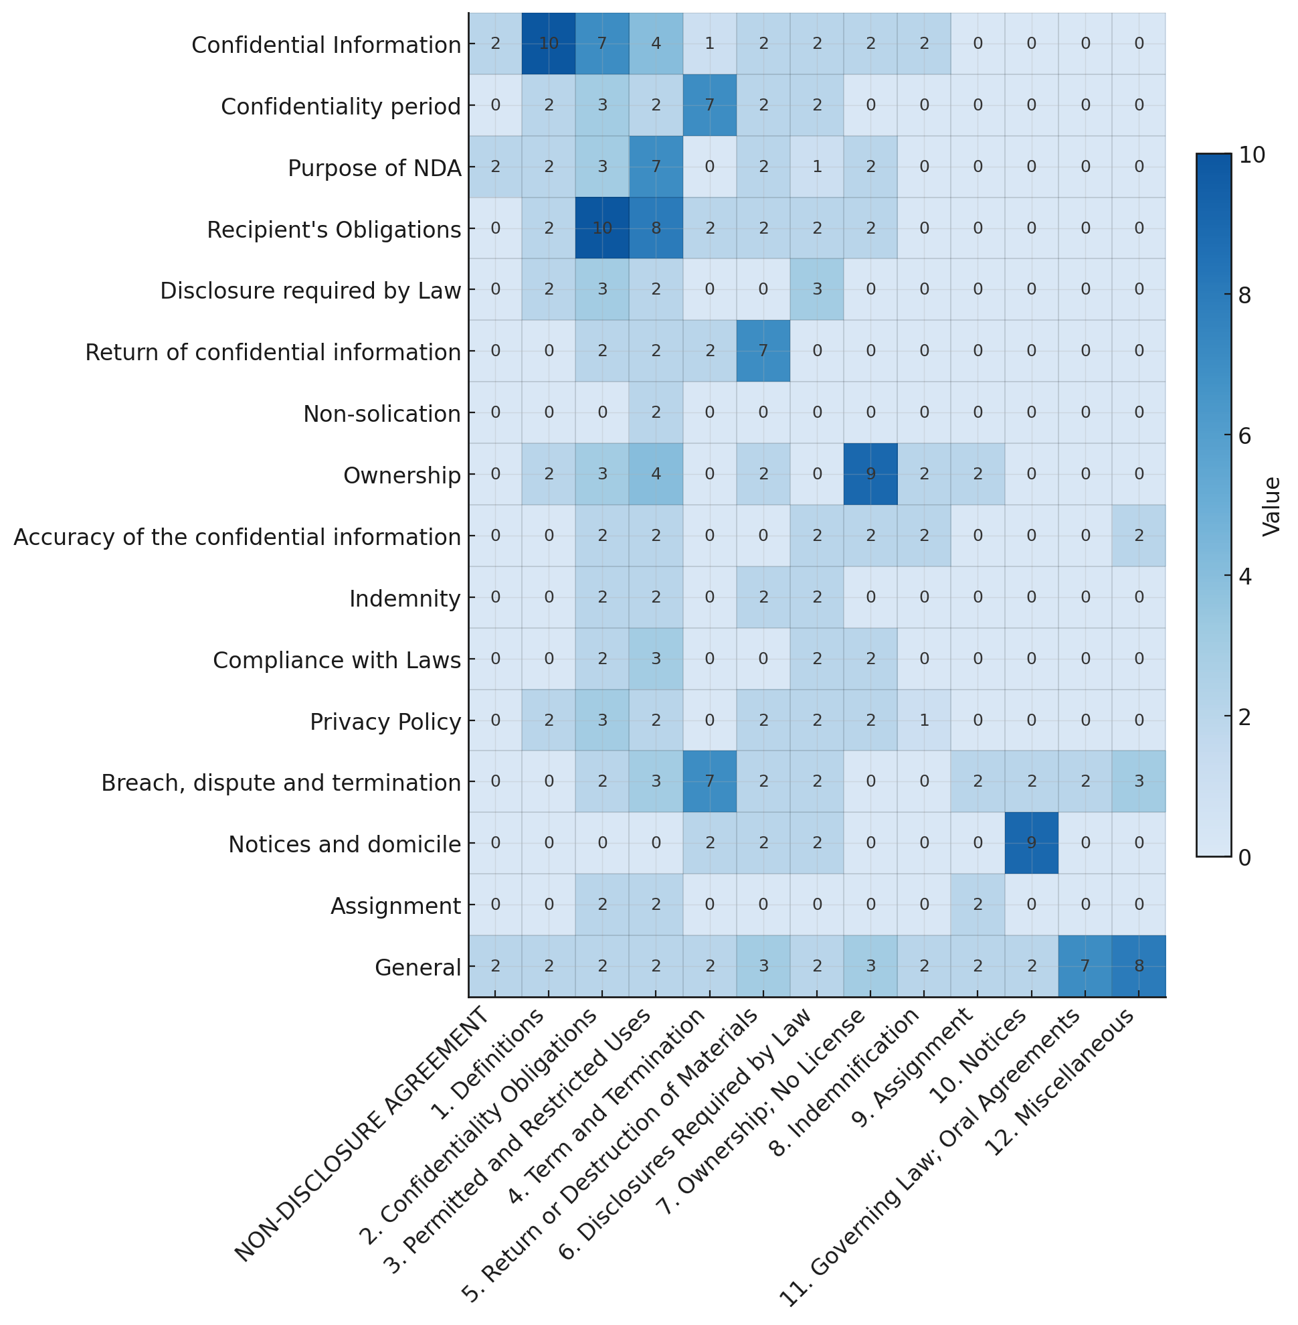

**What the Heatmap Shows** Figure 2 illustrates the heatmap of mutual similarity scores produced when the *first* (LLM-based) stage of our **Playbook-to-NDA Mapper** generated a matrix of all pairwise match scores (Playbook × NDA clauses). When comparing every NDA clause against the **General** Playbook clause, the LLM heatmap scored **“Miscellaneous”** at **8** and **“Governing Law; Oral Agreements”** at **7**, while all other clauses scored much lower (mostly 2s and 3s). This indicates strong semantic proximity for both sections relative to the policy.

**Why This Matters (Real-World Robustness)**

* If “General” language is split across sections, the system still finds it.
* Labels (“Miscellaneous” vs. “Governing Law”) do not mislead the system; content governs.
* In this evaluation, both human and AI surface the same risk area, despite structural differences.

**In Summary**Our solution is intentionally designed to be **robust to variability in legal document structure and language**. By combining both semantic similarity (via embeddings) and precise substring matching, the system can reliably recognize when substantively similar clauses appear under different names, headings, or formats. This dual-pronged approach ensures that even when clause titles or ordering vary – and even when multiple NDA clauses could serve the same legal function – the mapping and redlining pipeline remains accurate. The underlying design principle is to prioritize **semantic intent** over superficial or lexical similarity, allowing for consistent performance across diverse and unpredictable contract drafts.